How to get these values in R.

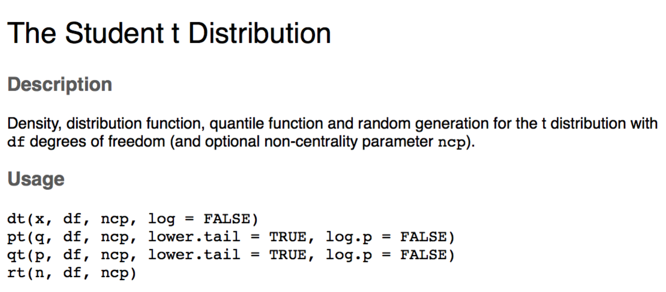

Which one should you use?

* P = probability distribution function
  + This function gives you the p-value associated with a specific t(df) combination.
  + q = t, df is either N-1 (single, dependent) or (n-1+n-2) (independent)
* Q = quantile distribution function
  + This function gives you the t cut off for an associated p and (df) combination.
  + p = alpha/p value, df is either N-1 (single, dependent) or (n-1+n-2) (independent)

Try:

